Introduction:
A plate is a flat structural element for which the thickness is small compared with the surface dimensions. The thickness is usually constant but may be variable and is measured normal to the middle surface of the plate, Fig.1.
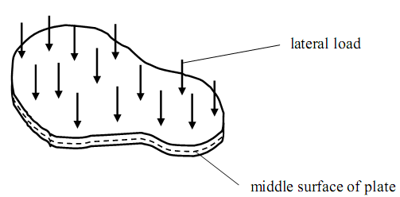
Fig.1: A plate
Objective:
Make the students familiar with the finite element theory behind standard plates.

Plate Theory:
Plates subjected only to in-plane loading can be solved using two-dimensional plane stress theory. On the other hand, plate theory is concerned mainly with lateral loading. One of the differences between plane stress and plate theory is that in the plate theory the stress components are allowed to vary through the thickness of the plate, so that there can be bending moments, Fig.2.
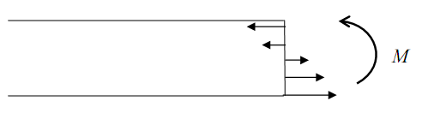
Fig.2: Stress distribution through the thickness of a plate and resultant bending moment
Plate theory is an approximate theory; assumptions are made and the general three dimensional equations of elasticity are reduced. It is very like the beam theory – only with an extra dimension. It turns out to be an accurate theory provided the plate is relatively thin (as in the beam theory) but also that the deflections are small relative to the thickness.
Things are more complicated for plates than for the beams. For one, the plate not only bends, but torsion may occur (it can twist), as shown in Fig.3
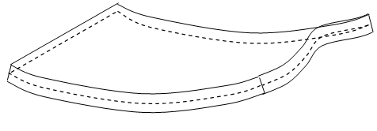
Fig.3: torsion of a plate
Assumptions of Plate Theory
Let the plate mid-surface lie in the x − y plane and the z – axis be along the thickness direction, forming a right handed set, Fig.4.
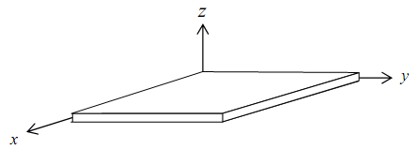
Fig.4: Cartesian axes
The stress components acting on a typical element of the plate are shown in Fig.5.
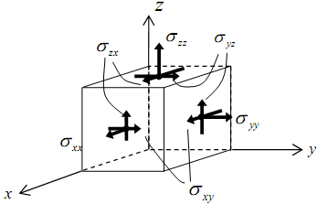
Fig.5: stresses acting on a material element
The following assumptions are made:
(i) The mid-plane is a “neutral plane”
The middle plane of the plate remains free of in-plane stress/strain. Bending of the plate will cause material above and below this mid-plane to deform in-plane. The mid-plane plays the same role in plate theory as the neutral axis does in the beam theory.
(ii) Line elements remain normal to the mid-plane
Line elements lying perpendicular to the middle surface of the plate remain perpendicular to the middle surface during deformation, Fig.6; this is similar the “plane sections remain plane” assumption of the beam theory.
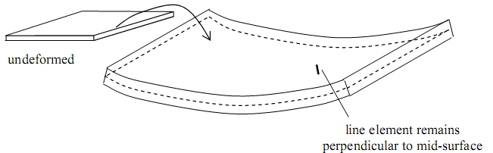
Fig.6: deformed line elements remain perpendicular to the mid-plane
(iii) Vertical strain is ignored
Line elements lying perpendicular to the mid-surface do not change length during deformation, so that ε_{zz} = 0 throughout the plate. Again, this is similar to an assumption of the beam theory. These three assumptions are the basis of the Classical Plate Theory or the Kirchhoff Plate theory.
Notation and Stress Resultants
The stress resultants are obtained by integrating the stresses through the thickness of the plate. In general there will be
Moments M: 2 bending moments and 1 twisting moment
Out-of-plane forces V: 2 shearing forces
In-plane forces N: 2 normal forces and 1 shear force
They are defined as follows:
In-plane normal forces and bending moments, Fig. 7
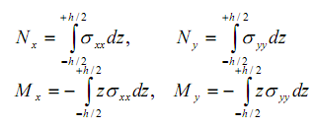
Bending moments (per unit length): (N.m/m)
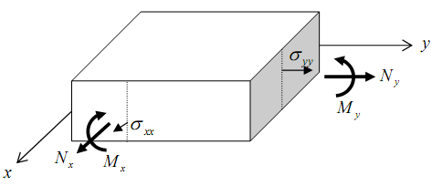
Fig.7: in-plane normal forces and bending moments
In-plane shear force and twisting moment, Fig.8:
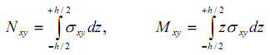
Twisting moment (per unit length): (N.m/m)
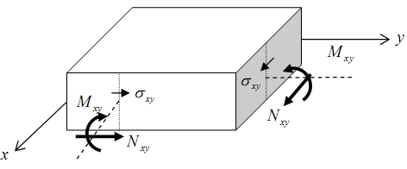
Fig.8: in-plane shear force and twisting moment

Out-of-plane shearing forces, Fig.9
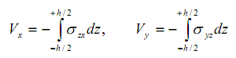
Shear Forces (per unit length): (N/m)
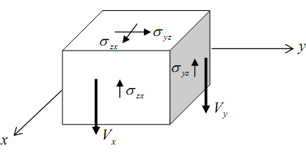
Fig.9: out of plane shearing forces
Applications:
• Shear walls, Floor panels, Shelves, floor slabs, bridge decks, sides of rectangular water tanks and other fluid retaining structures.
Thin Plate Theory (Kirchhoff Plate Theory)
The Kirchhoff plate theory is for relatively thin plates, and is analogue to the Euler- Bernoulli theory for beams. In particular, the assumption that plane sections remain plane and perpendicular to the neutral axis is maintained and generalized. In classical plate theory it is also common to let plate stretch in the x-y directions, and to let the z-axis point downwards.
Assumptions (similar to those in the beam theory):
A straight line along the normal to the mid surface remains straight and normal to the deflected mid surface after loading, that is, these is no transverse shear deformation:
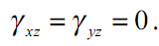

Displacement:
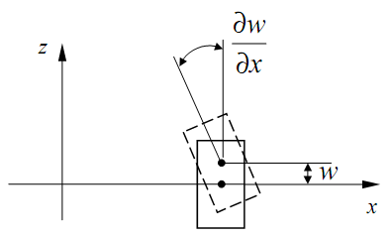
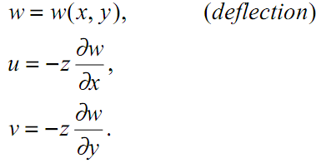
Strains:
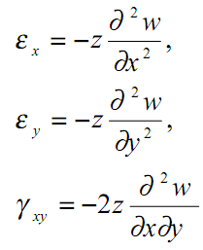
Note that there is no stretch of the mid surface due to the deflection (bending) of the plate.
Stresses (plane stress state):
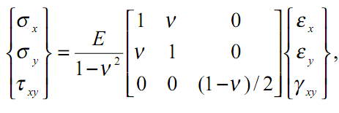
or,
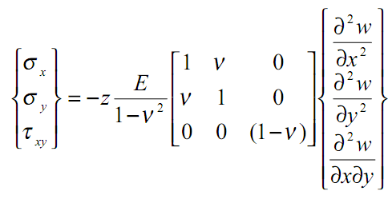
Main variable: deflection w = w (x, y)
Governing Equation:
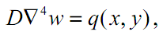
Where
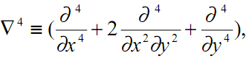
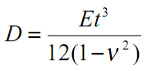(the bending rigidity of the plate),
q = lateral distributed load (force/area).
Boundary Conditions:
Clamped: 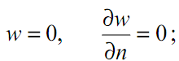

Simply supported:

Free: 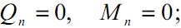

The maximum deflections are given in the following table for the different cases.
Deflection at the Center (w_{c})
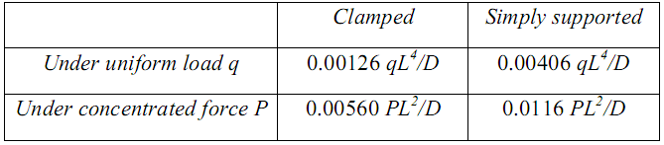
in which: 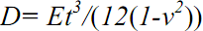
These values can be used to verify the FEA solutions.
Manual:
Simply Supported Rectangular Plate
Calculate the deflection at the center of a simply supported isotropic plate subjected to:
A. Concentrated load F = 400 lbs, and
B. Uniform pressure P = 1 psi.
Dimensions of the plate are as follows: h = 1 in, a = b = 40 in.
Material Properties: Modulus of elasticity = 3 X 10⁷ psi, Poisson's ratio = 0.3.
CASE | Plate width | Plate length | Plate thickness | Modulus of Elasticity | Poisson’s ration | Deflection
Uniform Load
Concentrated force

Quiz:
1) What is a Plate?
A plate is a particular form of a three-dimensional solid with a thickness very small compared with other dimensions.
2) Difference between plate and Shell element?
Ans: Plates may be considered similar to beams, however: Plates can bend in two directions and twist. Plates must be flat (or else they are shells).
Shell elements are different from plate elements in that: They can be curved, They carry membrane and bending forces.
3) Mentioned the different plate boundary conditions and their physical interpretation?
4) What type of forces is predominant in plates?

